**Executive Summary:**

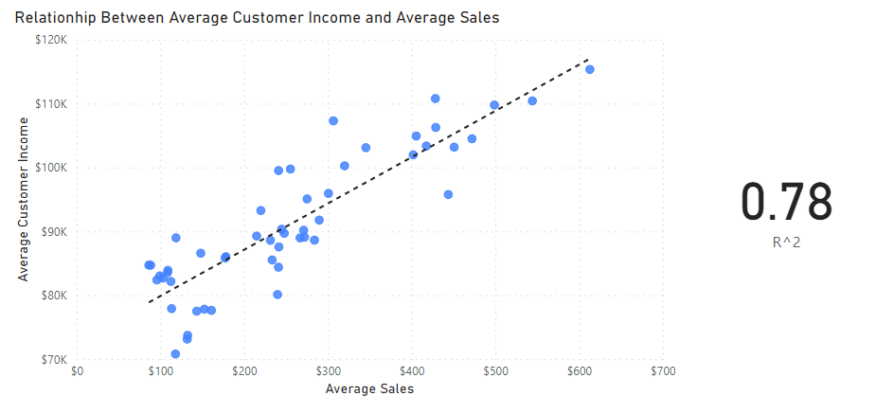

The regression analysis showing the correlation between customer income and sales. It shows that there is a strong positive relationship between the two variables with correlation R^2 of 0.78.

The regression analysis showing the correlation between customer rating and return rate. It shows that there is a moderate negative relationship between the two variables with correlation R^2 of 0.69.

The linear regression formula to predict sale is x = y - 72638.21/ 7.43 where x is the sales and y in the customer income.

The linear regression formula to predict customer income is y = 7.43X + 72638.21 where y is the customer income and x is the sales.

The customer with the highest predicted income is Jhon little with the customer id JLit30836

The histogram chart shows the distribution of predicted customer income. The distribution is right skewed towards the lower buckets peaking at $90k. This means that most of the customers income falls under $100k. Therefore, they will mostly be being the cheapest product being the shirt. Thus, its recommended to advertise shirt the most.

The line chart shows the number of purchases of the customers during the year. The line shows that most of the purchases are happening between specific periods of the year. During November 2020 to Jan 2021 there were the highest number of purchases. Another period was between Sept 2020 to Oct 2020. This suggests that its good to focus on these periods when advertising. Also, it shows the part of year where you can improve to enhance sales.

The bar chart shows the return rate of different product. The top products have the lowest rate of return. From the regression analysis conducted between customer rating and return rate. We concluded that the higher return rate the lower the customer's rating. This align with our recommended product as the polo shirt is having a low return rate thus high customer satisfaction. Also, with a price of 35$, it falls in the group for most customer income.

The bar shar shows that California holds the highest number of purchases in the last 6 month with 64k.

**Final Recommendation:**From the results of the statistical analysis, we recommend to:

1. Focus the marketing campaign on the shirt product.
2. Capitalize on the periods of highest number of purchases that is between September-October and December-January.
3. Target the customers with the average income lower than $100k.
4. Target California since Customers in California tend to purchase more items than any other state.